Susan McNamee
772-333-0556
smcnamee@lidtech.com
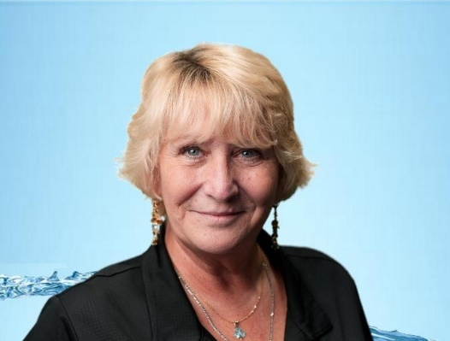
I began my career in stormwater management in 1998 with Infiltrator Systems where the StormTech Chamber was developed from out of septic chambers. I assisted engineers with the design, sizing and laying out of they systems using AutoCAD.
As the company expanded I advanced into operations while continuing to support CAD work and system sizing. My expertise grew as I tackled storage volume calculations, flow management, and water quality enhancements, honing my skills in a fast-paced, technical environment.
In 2009, I relocated to the Midwest to serve as an outside technical manager. Immersing myself in the region’s unique stormwater regulations, I attended many training seminars at the University of Minnesota, where I gained a deeper understanding of Total Phosphorus (TP) and Total Nitrogen (TN) in stormwater. 2010 Advanced Drainage systems bought StormTech. This knowledge was useful when I moved to Florida in 2012 where I expanded my knowledge to include pipe systems, drain basin design, and conveyance pipe integration, all while maintaining my passion for chamber systems and water quality solutions.
In 2017, I joined Hydro International, focusing exclusively on stormwater quality. I refined my technical skills, learning to size systems using TR-55 and the Rational Method. Collaborating with the Florida Department of Environmental Protection (FDEP) and regional Water Management Districts, I worked to address critical water quality issues.
I held a License with FBPE from 2017 – 2025(CEA720) under Hydro International. Nov 2024 I have joined LIDTech. I have applied and been approved by FBPE in 2025 for LIDTech.
Throughout my career, I’ve pursued continuous learning, earning a Bachelor of Science in Business Management (2003) and completing numerous stormwaters training programs, including the Certified Stormwater Quality Professional (CSWQP) course.
Outside of work, I cherish the outdoors. Whether camping, hiking, fishing, canoeing, paddleboarding, or enjoying Florida’s beaches, I’m passionate about nature. My commitment to the environment extends to volunteer activities, such as beach cleanups. I’m also a proud grandmother, drawing inspiration from my family to protect the environment for future generations.
Breaking into the stormwater field as a woman over 25 years ago posed unique challenges, but those challenges fueled my determination to excel. Through hard work and perseverance, I’ve earned a strong reputation and the respect of colleagues in the engineering and government sectors.
Today, I remain dedicated to advancing stormwater solutions that safeguard our environment and support the communities I serve. For me, this work is not just a career, it’s a calling to create a cleaner, healthier world for generations to come.

